Ideation Phase
Brainstorm & Idea Prioritization Template
Date | 9 July 2026
Team ID
Project Name | ShopEZ
Maximum Marks | 4 Marks

Step-1: Team Gathering, Collaboration and Select the Problem Statement

Team Discussion
Our team discussed different project ideas such as a Food Delivery System, Learning Management System, Pharmacy Management System, and E-Commerce Platform. We compared them based on usefulness, technical learning, and future scope.
After discussion, we selected ShopEZ, a MERN-based e-commerce platform. It allows customers to shop online while sellers, delivery managers, and administrators manage their tasks through separate dashboards.

Problem Statement
Many small businesses need a simple platform to manage products, orders, payments, and deliveries. Existing solutions are often expensive or difficult to manage.
ShopEZ aims to provide one platform where customers can shop easily and sellers, delivery managers, and admins can efficiently manage their work.
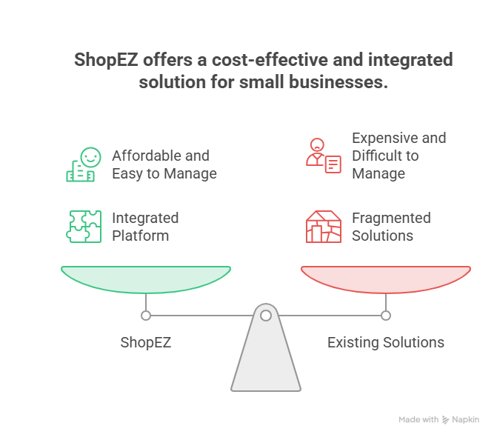

Step-2: Brainstorm, Idea Listing and Grouping

Ideas Discussed

Idea | Result
Food Delivery System | Not Selected
Learning Management System | Not Selected
Pharmacy Management System | Not Selected
ShopEZ E-Commerce Platform | Selected

Features Brainstormed

Customer
- Login & Registration
- Product Search
- Cart
- Wishlist
- Checkout
- Reviews
- Order Tracking

Seller
- Add Products
- Manage Inventory
- View Orders

Delivery Manager
- Assigned Orders
- Update Delivery Status

Admin
- Manage Users
- Manage Categories
- View Orders
- Support Tickets

Additional Features
- Coupons
- Flash Deals
- Price Alerts
- Reorder Reminder

Idea Grouping

Category | Features
Customer | Search, Cart, Wishlist, Checkout
Seller | Products, Inventory, Orders
Admin | Users, Categories, Reports
Delivery | Shipment Updates
System | JWT Login, Razorpay, MongoDB

Step-3: Idea Prioritization
